# Lab: Intro to DOM

Problems for in-class lab for the ["JS Fundamentals Course @SoftUni"](https://softuni.bg/trainings/2247/js-fundamentals-january-2019). Submit your solutions in the SoftUni judge system at <https://judge.softuni.bg/Contests/Practice/Index/1425>

1. **Articles List**

In this problem, you should create a JS functionality which creates articles and appends them into some article section.

The programs in this language are called **scripts**. They can be written right in the HTML and **executed** **automatically** as the page loads.

Scripts are provided and executed as a **plain text**. They don't need a special preparation or a compilation to run.

In this aspect, JavaScript is very **different** from another language called Java.



### Constraints:

* **Title value** from the **title input** should be a **heading 3 element <h3>**
* **Content text** from the **textarea element** should be a **paragraph <p>**
* Both new created elements (**h3** and **p**) should be appended to a new **article element <article>**
* **The current article element** should be **appended** to the section which has an id articles (**#articles**)
* You should create new **article element** only if **title** and **content are not empty**
* After the button is pressed you must **clear** the **title value** and **text value**

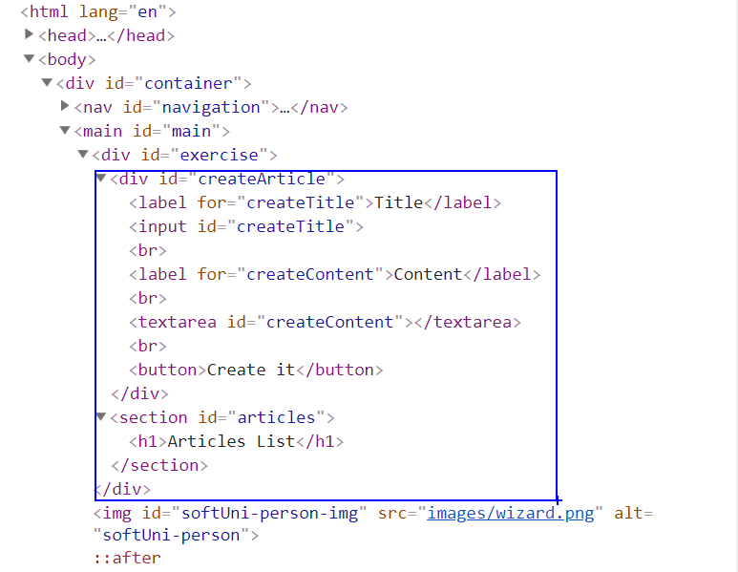

### Input:

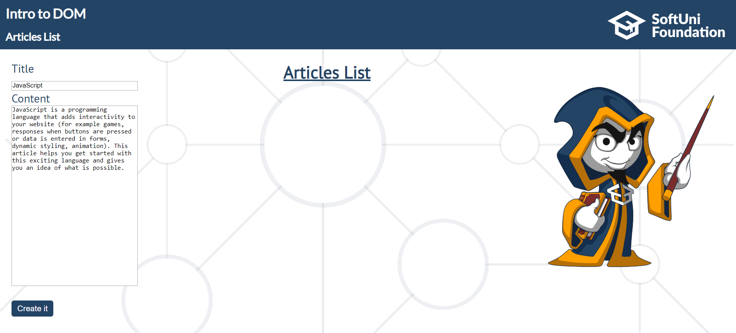

### Output:

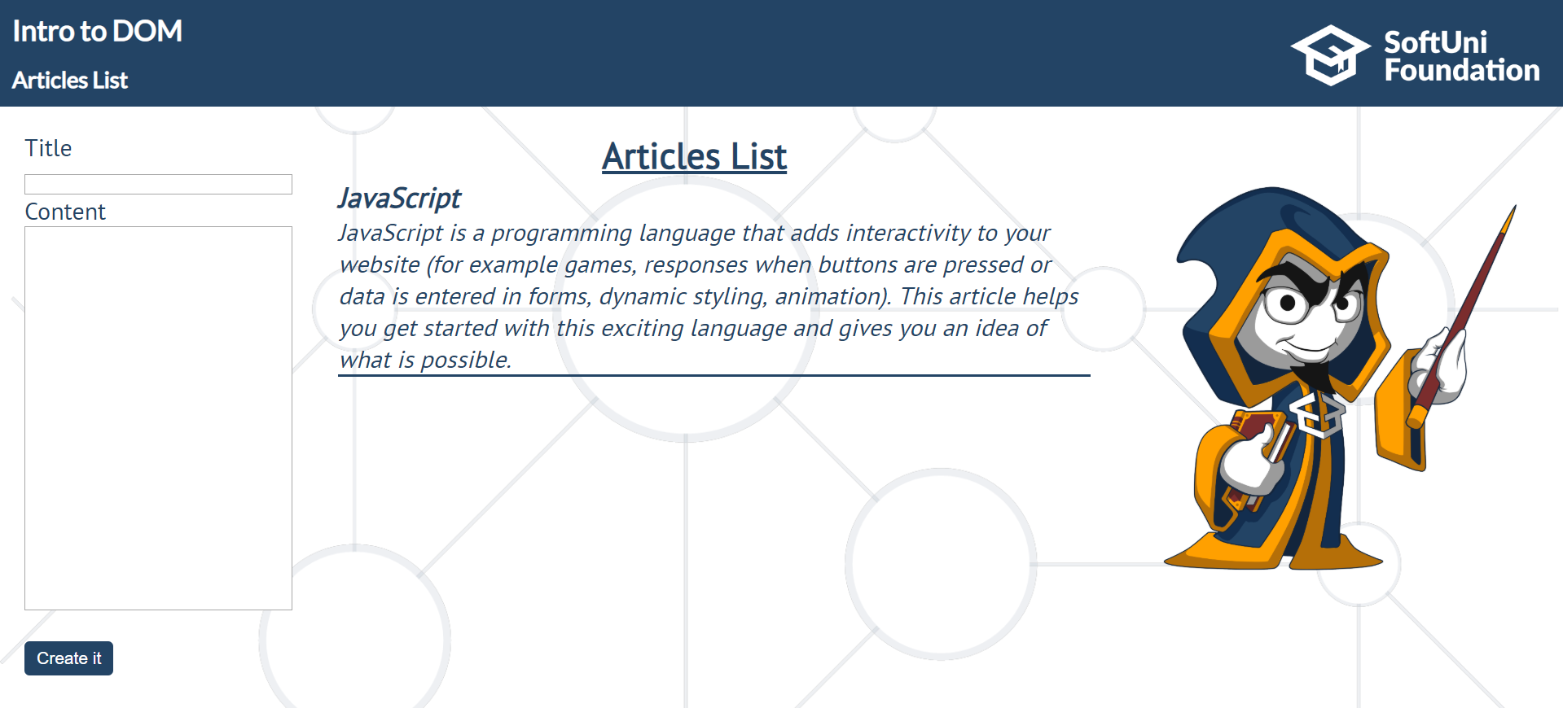

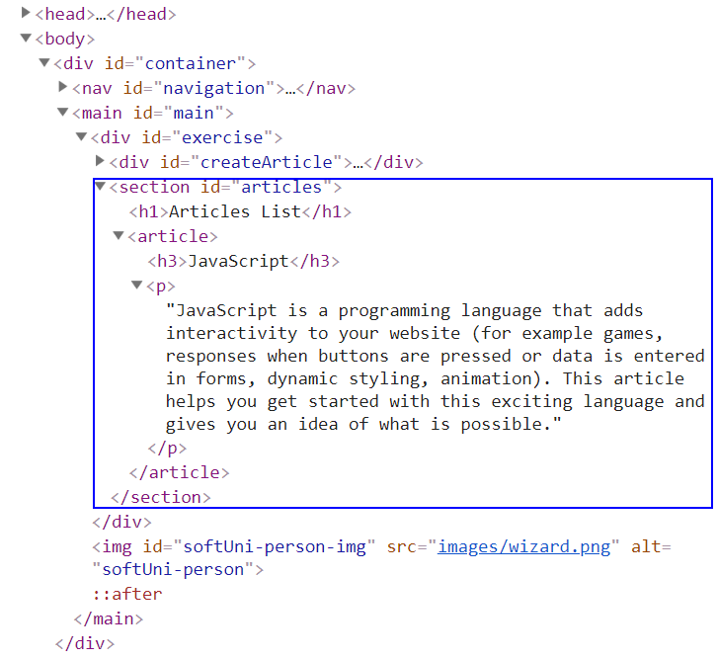

## Format the Text

In this problem, you should **create a JS functionality** which **formats the given text into paragraphs.**

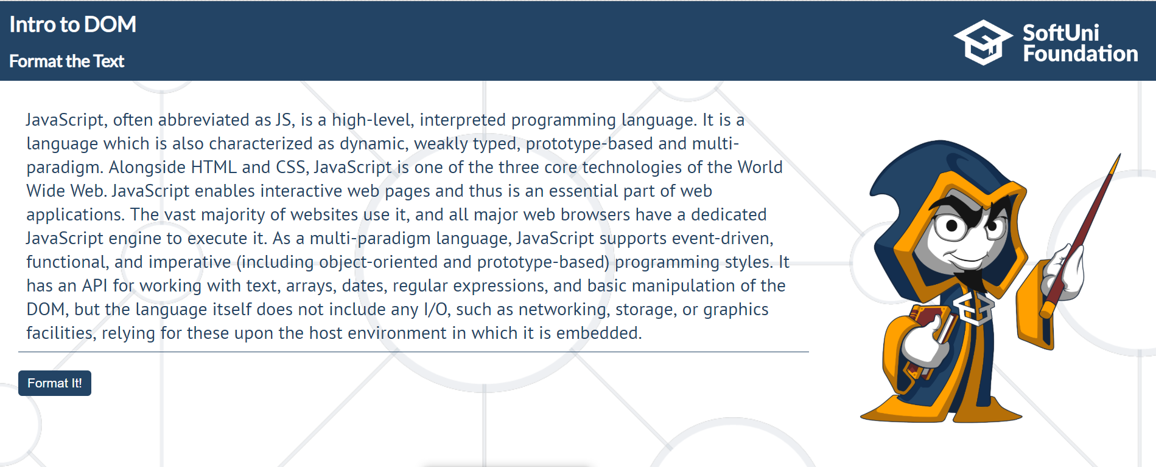

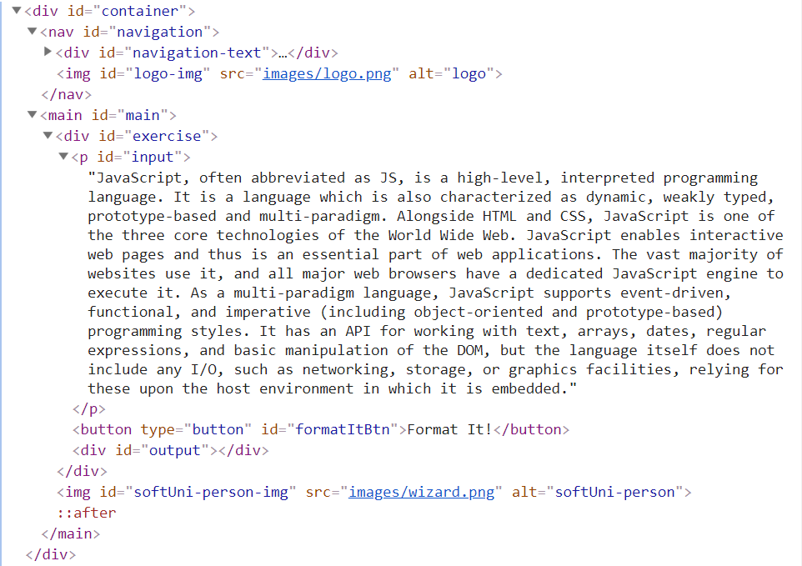

When the [**Format it!**] button is **clicked**, you need to **format the text** **inside** the **paragraph** with an **id** "**input**". The formatting is **done** as **follows:**

* You need to **create a new paragraph element which holds no more than 3 sentences from the given input.**
* If the given input contains **less** or **3 sentences**, you need to create only 1 paragraph, fill it with these sentences and append this paragraph to the div with an **id** "**output**".

Otherwise, when you have more than 3 sentences in that **input paragraph,** you need to create enough paragraphs to get all sentences from the **input text.**

Just remember to **restrict** the **sentences** in **each paragraph to 3.**

### Example:

* If the input paragraph **contains 2 sentences**, you need to create only **1 paragraph** with these 2 sentences
* If the input paragraph **contains 7 sentences,** you need to create **3 paragraphs**  
  - The **first paragraph** must contain **the first 3 sentences**  
  - The **second paragraph** must contain **the other three sentences of the whole text**  
  - The **third paragraph** will contain **only the last sentence**, because there are no more sentences in this paragraph

**To find out how many sentences there are in the text, simply split the whole text by '.' Also, every sentence must have at least 1 character.**

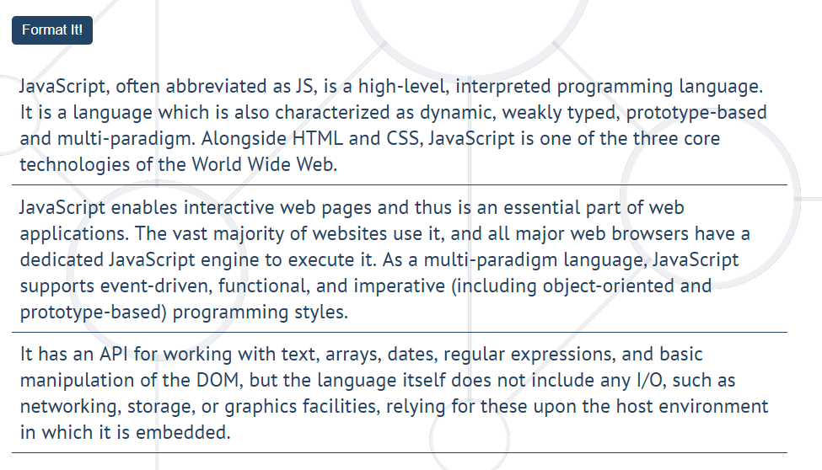

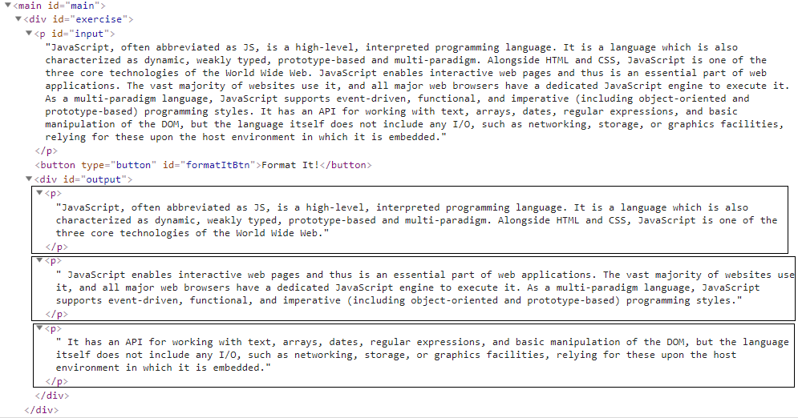

## Growing Word

In this problem, you should **create a JS functionality** which **changes the size and the color** of a given **paragraph** on **every click**.

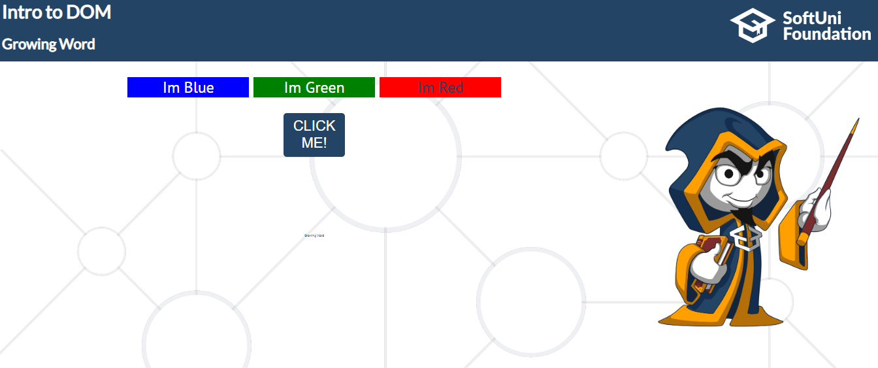

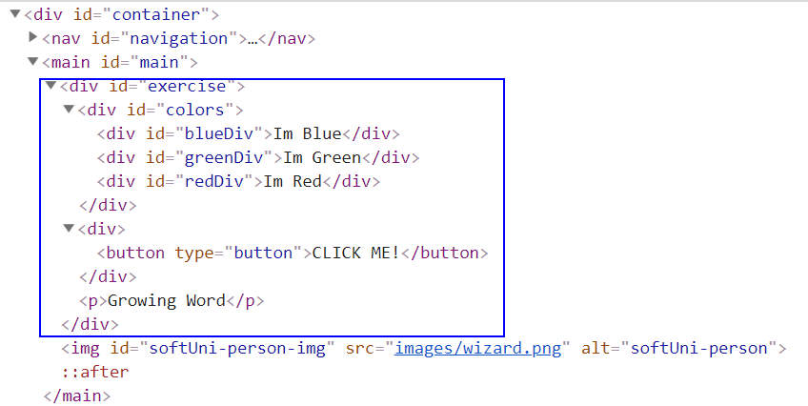

Every time when we **click** on the [**CLICK ME!**] button, **the color** and **the size** of **the paragraph** which contains "**Growing Word**" **should change!**

**After every click,** the current paragraph *font size* should be **changed** to the **total current clicks multiplied by 2.** Also **the color** of that paragraph should change, depending on the **total clicks**.

### Example:

If we click **once**, the color should be changed to **blue**, if we click **twice,** **the color** should be changed to **green** and if we click **three times**, the current color of that paragraph should be changed to **red**.

If our paragraph already has a **red color, on** the **next** click, the color should turn to **blue**. Just loop throw these three colors (blue, green, red) again and again and again... while you are clicking on that button.

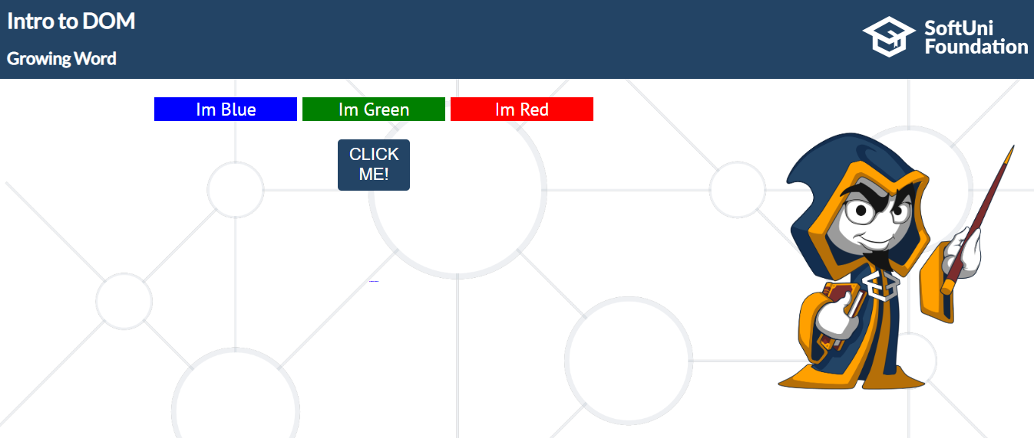

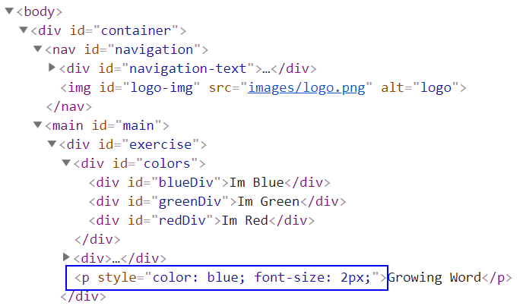

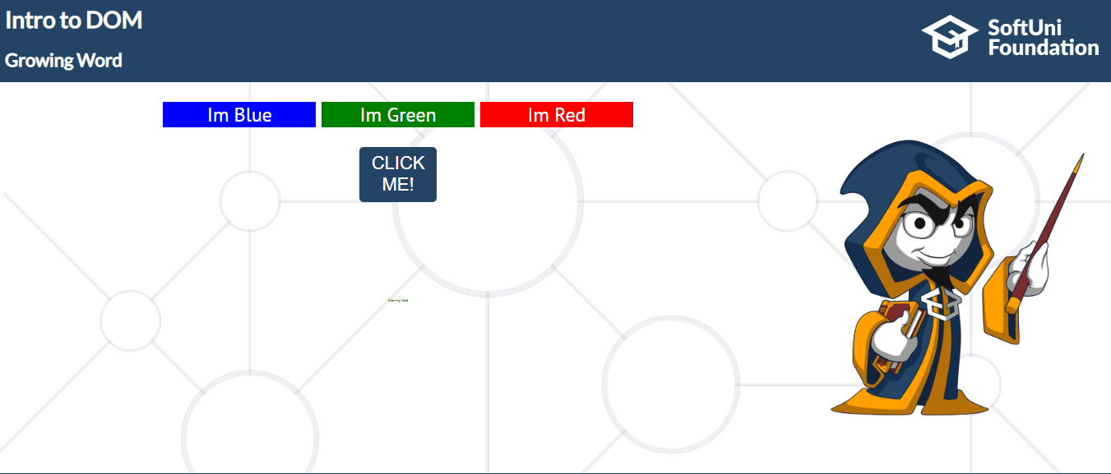

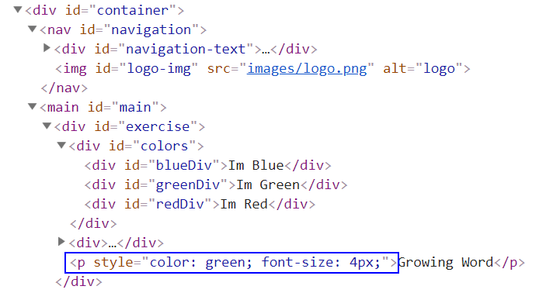

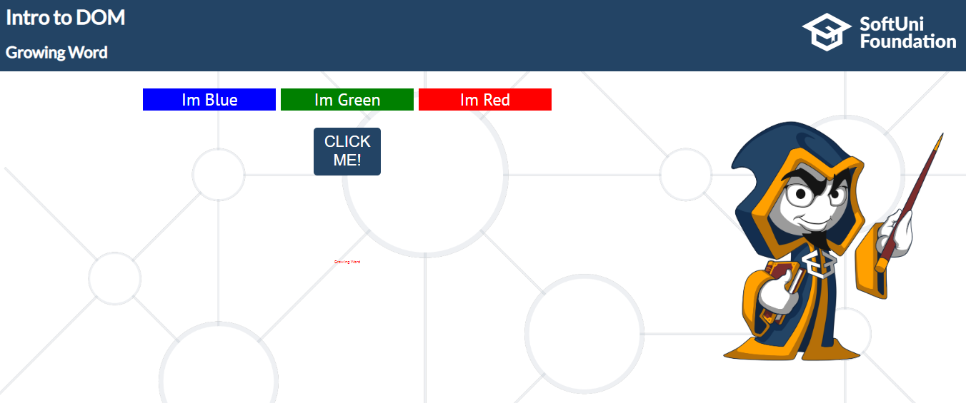

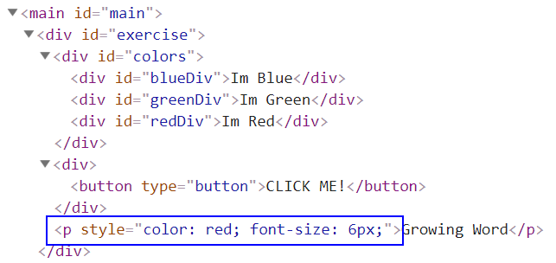

## Register Notification

In this problem, you should **create a JS functionality that** shows notification after successful

registration.



### Constraints:

* The username should be a **non-empty string**
* The email address should match the current RegEx: **/(.+)@(.+).(com|bg)/gm**
* The password should be a **non-empty string**

When these conditions **are met** and after a click on the [**Register**] button, the following

notification should appear for **5000 ms**. *(use the* ***setTimeOut*** *function to do this)*

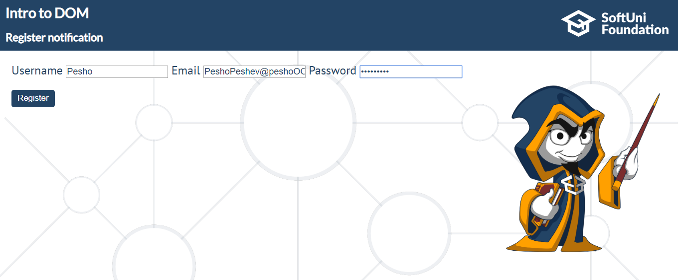



The current information must be added to the section with an **id - result.**

The message should be in the following format:

**'Successful Registration!'** *(must be in h1 tag)*'**Username: ${currentUsername}**'

**'Email: ${currentEmail}'**

**'Password: ${currentPasswordLength in asterixes (*)}'**

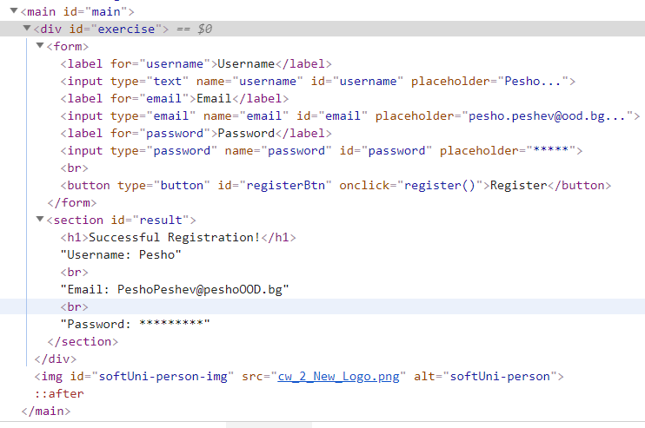

## Visited Sites

In this problem, you should **create a JS functonality** that keeps track of how many times a

specific site has been **visited**.

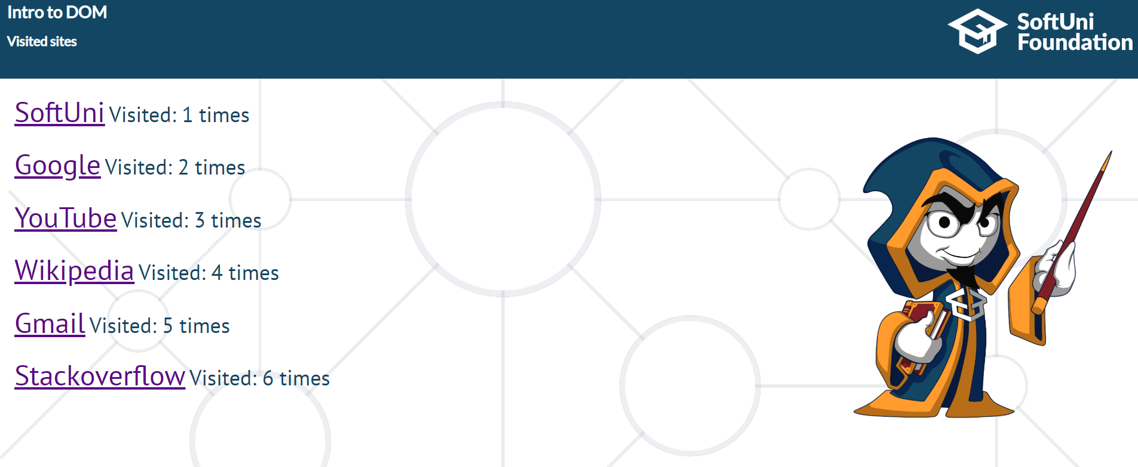

For instance, if we click **twice on the Gmail link and once on the Youtube link**, the expected

result must be:

